**/* 30. wap in c++ to copy one text file into another after removing white spaces */**

using namespace std;

#include<iostream>

#include<fstream>

int main()

{

ifstream fin;

ofstream fout;

char ch;

cout<<"Begin file copy";

fout.open("file.txt");

if(!fout)

{

cerr<<"error in opening file";

exit(0);

}

fout<<"Computer science - A structured approach using c++\n";

fout.close();

fin.open("file.txt");

fout.open("newfile.txt"); //new file

if(!fin)

{

cerr<<"error in opening file";

exit(0);

}

if(!fout)

{

cerr<<"error in opening new file";

exit(0);

}

while(fin.get(ch))

{

if(ch!=' ')

fout.put(ch);

}

fin.close();

fout.close();

cout<<"\nEnd file copy\n";

system("pause");

return 0;

}

**/\*** Output:-

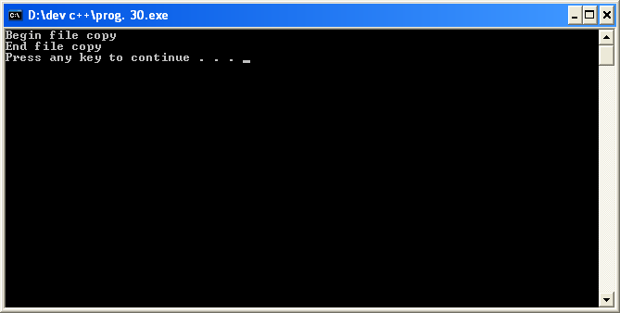

**Data in file:-**

Computer science - A structured approach using c++

**Data in new file(copied file):-**

Computerscience-Astructuredapproachusingc++ **\*/**